package firstpackage;
public class Arithemetic_Operators {
public static void main(String[] args) {
int Maths = 89;
int Science = 76;
int English= 92;
int TotalMarks= Maths + Science + English;
int AverageMarks = TotalMarks/3;
System.out.println("TotalMarks: " + TotalMarks);
System.out.println("AverageMarks: " + AverageMarks);
}
}

Data type is int –
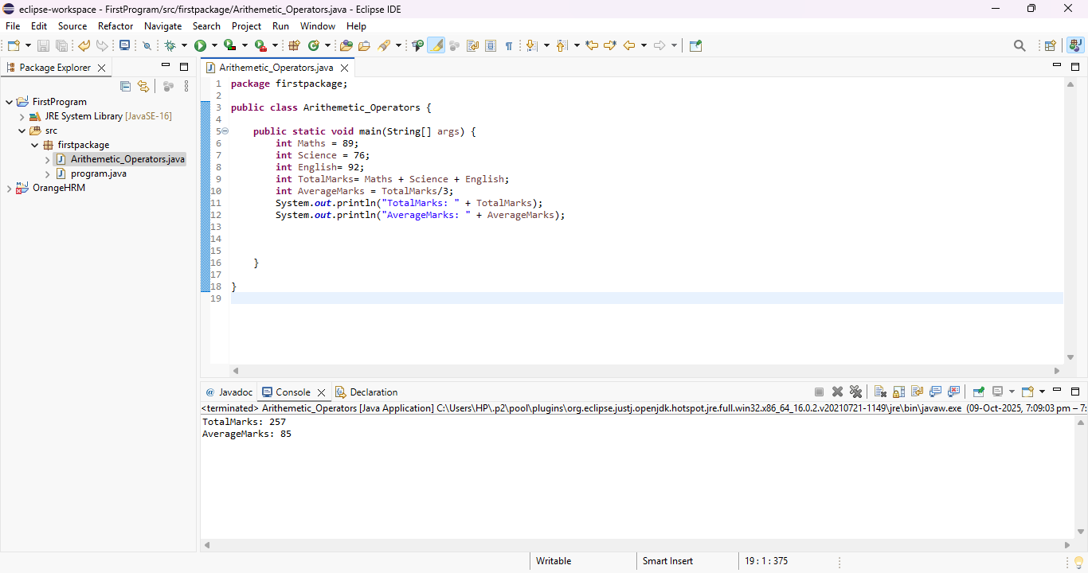

Data type is double –
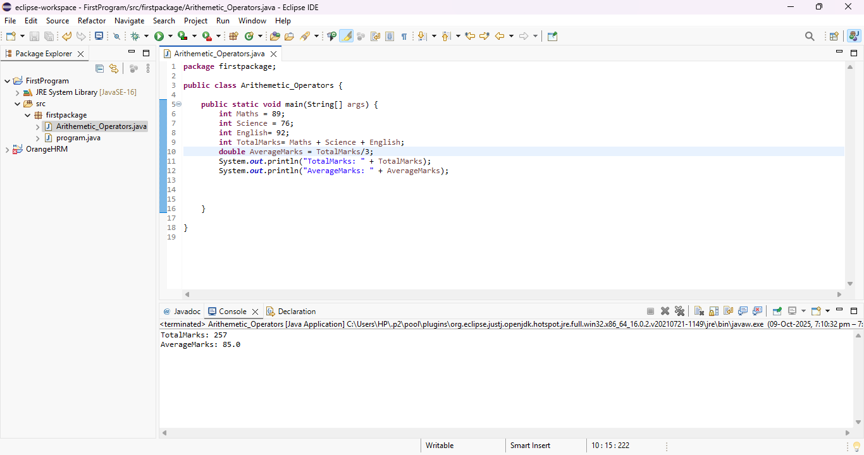

Data type is float –

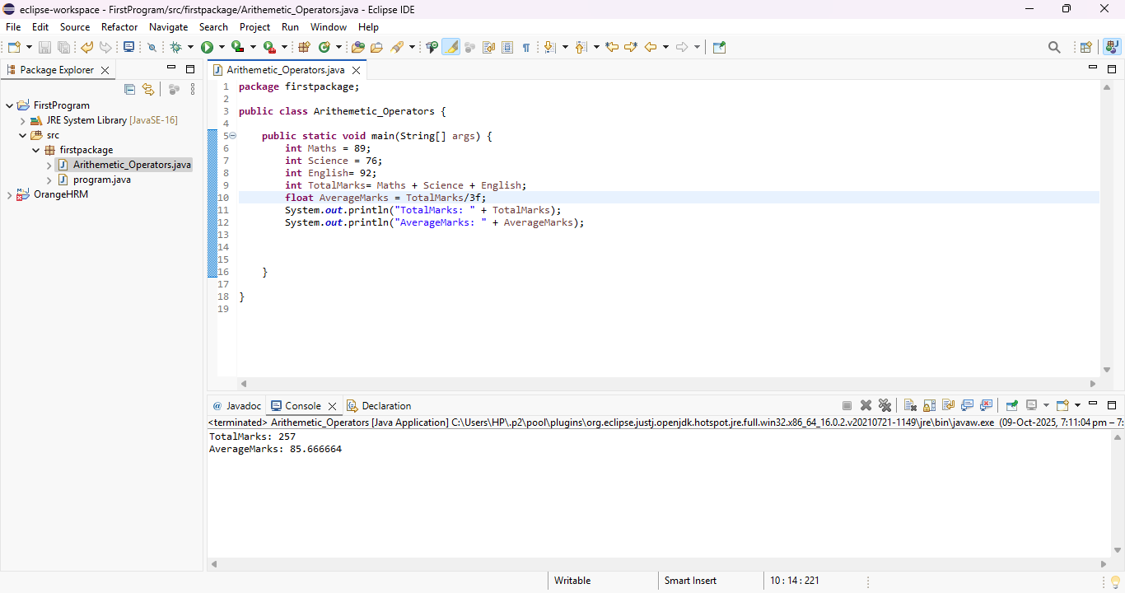

Data type is char -
